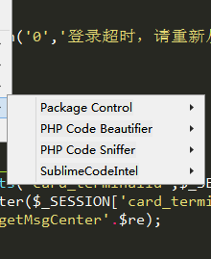
PHPCS
Laravel snippet
Php snippet

